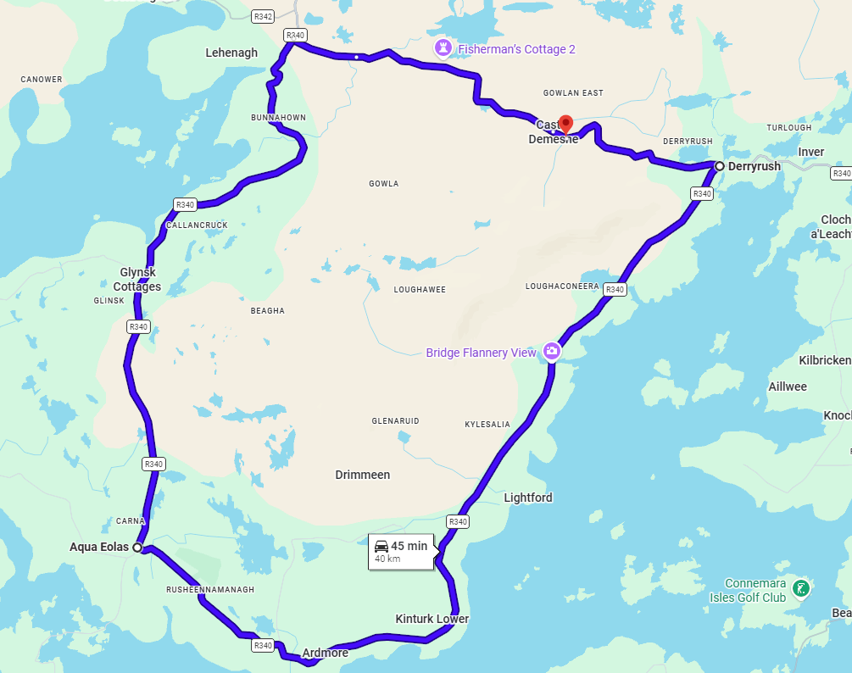
Bridge Closed Here
Eastbound Traffic Diversion Route
Westbound Traffic Diversion Route
Local Access Only – No through road between points as indicated

