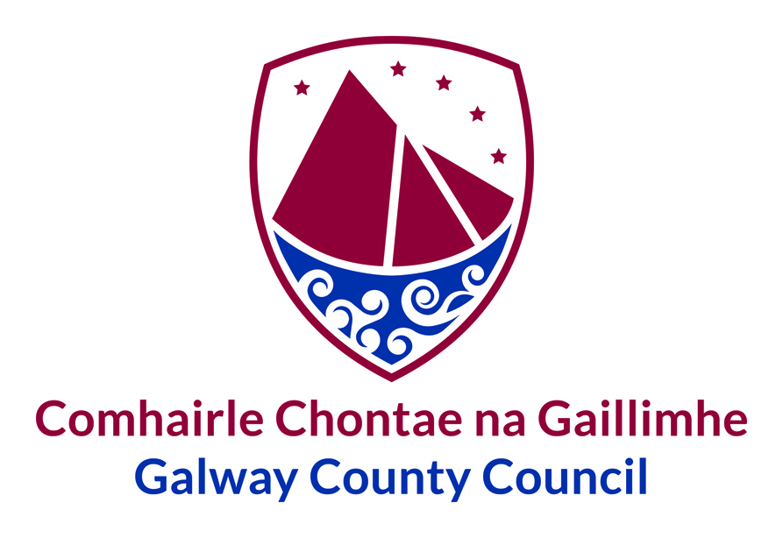
Applications are invited from suitably qualified persons for the following post:
CALL FOR RETAINED/ PART-TIME FIRE FIGHTERS: INIS MÓR

- A recruit Firefighter shall be in a state of health such as would indicate a reasonable prospect of ability to render regular and efficient service.
- A recruit Firefighter must have attained a satisfactory level of education to enable them to perform satisfactorily as a Firefighter and to successfully undergo the appropriate training.
- A recruit Firefighter shall possess a valid full current Category B Driving Licence at the time of applying for the post.
- A recruit Firefighter must live and work within a maximum of 8 minutes travel time from the assigned Retained Fire Station, to allow them to respond for the duration of their employment as a Firefighter.
- Firefighters are required to be available and attend alerts 24 weeks in the year on a rostered-on/flexible basis.

A Firefighter receives an annual retainer fee in line with length of service:
Retained Fire Fighter | 01/02/2026 pay scales
Months of service | Duration on Point | Salary
On appointment-12 months | 1 year | €16,852
12–48 months | 3 years | €17,864
48–84 months | 3 years | €19,112
84+ months | Until cessation | €20,251

Additionally, Firefighters will be paid for attendance at fires at the following rates:
Basic Hourly Rate  (Drill Rate) | Standard Attendance Rates |  | Premium Attendance Rates
Basic Hourly Rate  (Drill Rate) | 1st Hour | Subsequent Hours | 1st Hour | Subsequent Hours
€26.04 | €52.08 | €26.04 | €104.16 | €52.08

Other attendance renumeration includes:
Hourly Attendance at Drills (Double Drill Rate) | €52.08
Community Fire Safety Annual Payment (40 hours at Basic Rate Annually) | €40.06
Community Fire Safety Payment - Hourly | €26.04

Promotional opportunities may arise in the Retained Fire Service with opportunities for higher retainer fees. Application forms and further details of this post are available on our website at www.galway.ie or may be obtained by contacting the Human Resources Department, Galway County Council, Áras an Chontae, Prospect Hill, Galway – Tel; 091 509 303, e-mail hr@galwaycoco.ie.

Prior to interview, candidates will be required to undergo a work-related suitability test, this includes a number of physical and aptitude tests. Successful candidates will then be brought forward to interview.
Closing date for receipt of completed application forms is 4.00p.m. on Thursday, 19th March 2026.

E. Ruane, Director of Services.
GALWAY COUNTY COUNCIL IS AN EQUAL OPPORTUNITIES EMPLOYER

