Town & Village Renewal Scheme
Terms & Conditions

Killimor Streetscape Scheme

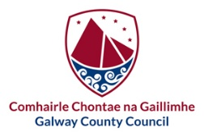

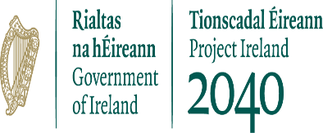
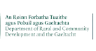

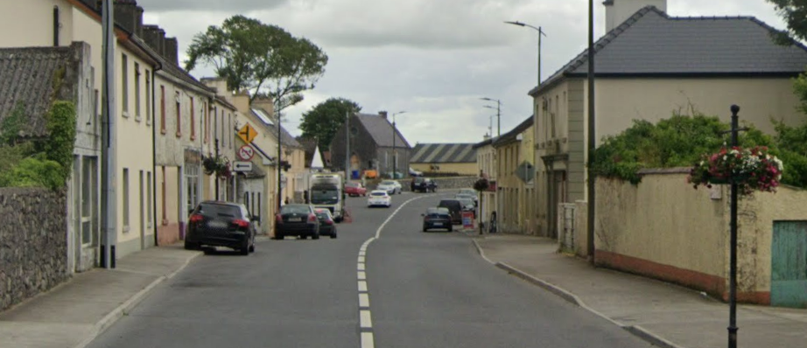

Please read these Terms and Conditions carefully before completing the application form.

Introduction

Galway County Council is pleased to offer a Streetscape Enhancement Scheme for Killimor. This activity is funded by the Department of Rural & Community Development and the Gaeltacht (DRCDG) under the 2025 Town & Village Renewal Scheme and as part of the roll-out of Our Rural Future.

Our Rural Future is the Government's strategy to revitalise rural Ireland. Improving the visual appearance of our urban streetscapes (town and village centres) increases pride and confidence in our villages, making them more attractive places to live, work and do business.

What is the Focus of the Steetscape Scheme ?

The Scheme is to encourage residents, tenants and shop owners to engage in best practice in restoring shopfronts and in the presentation of properties which face the main street. In order to create an strong visual impact over a defined period of time, the Scheme has a focus on village centres, quality materials to enhance the identity and aesthetic of the village.

The Scheme promotes using thoughtful lighting and signage, sign-writing, high quality materials and paint. The Scheme encourages greening enhancement of entrances/terraces/central community spaces with appropriate planting; decluttering (removal of unnecessary signs, wiring, flagpoles etc.. on buildings); painting and the use of a palette of colours, to highlight the qualities and specific features of building frontages in order to bring about a consistently high standard which reflects the local architecture and characteristics of the village and its surrounding areas.

It is the policy of the Council to preserve and retain traditional shopfronts that contribute to the character of the Towns and Villages of County Galway. Shopfronts are a very important element of the streetscape. Shopfronts should therefore, be of a high standard of design and reflect the architecture of the original building and of the surrounding area. The need to change old shopfronts whether protected or not will be closely questioned. Preference should be given to refurbishment rather than replacement. Regular inspection and maintenance is essential to avoid serious defects and decay.

Further Guidance on Shopfront and Street Facades is included in the Galway County Council Shopfront Design Guide.

The Streetscape Scheme includes a specific Grant Scheme for Property Owners and Tenants to apply for up 70% or 80% (when 3 neighbouring properties apply) for eligible enhancement works.

Who is eligible to apply ?

The following applicants may apply for grant aid:

Eligible Applicants

• Owners or tenants of commercial, residential, or unoccupied buildings located within the qualifying area of Killimor Village Centre (see map).
• Residents, occupiers, or lease holders of Local Authority–owned buildings within the qualifying area.
• Community and voluntary groups, where they apply:
• in consultation with the property owner/tenant, or
• on behalf of an unoccupied property within the qualifying area.

Applications Outside the Qualifying Area
• Applications for properties outside the defined zone may be considered on a case-by-case basis.

Additional Requirements
• Tenants must provide written consent from the property owner at the time of application.
• Applications may not be considered where local taxes, rates, or charges are outstanding, unless:
a payment plan is in place, and the applicant is meeting the agreed repayments.

What Works are Eligible for Grant Aid?

Enhancement works to commercial, residential, vacant, or derelict properties are eligible.

General Eligibility Notes
• It is preferable that works are carried out on adjacent properties, as a minimum of three neighbouring properties is required to qualify for the 80% funding rate.
• A single property application is eligible for 70% funding.
• Standalone applications for derelict or vacant buildings are permitted where the works will significantly improve the streetscape

Eligible Works

- Green Enhancement of Entrances/Terraces with appropriate planting
- Roof/Chimney/Guttering- removal of vegetation, cleaning and minor repairs (minimum 2 adjacent properties)​
- Painting of building/shop front in carefully selected colours which will complement the host building and streetscape. This includes Doorways, Windows, Key Features.
- Decluttering and repair of shopfronts. (Decluttering can include such works as removing unnecessary signs, flagpoles, wiring etc.)
- Repair/Replacement of side gates in laneway/archways in carefully selected designs appropriate to village setting
- Appropriate illumination and lighting of architectural features of buildings.
- Replacement of signage with traditional wooden fascia with wooden/hand painted lettering OR contemporary design
- Repair of traditional shopfronts- reinstallation of Fascia board, pilasters and other timber features.
- Canopies/Awnings complementary to the materials of the shopfront and building, including street furniture and in line with any Planning Requirements.

Notes
- The maximum amount of Grant Aid available for activities 1 & 2 is at 70%/80% of verifiable costs, to a maximum of €750 euro. This is for one individual activity or a combination of any of these type activities.
- The maximum amount of Grant Aid available for activities 3 & 4 is at 70%/80% of verifiable costs, to a maximum of €3,000 euro. This is for one individual activity or a combination of any of these type activities.
- The maximum amount of Grant Aid available for activity 5 is 70%/80% of verifiable costs, to a maximum of €1,800 euro.
- The maximum amount of Grant Aid available for activities 6,7 is €4,000. This is for one individual activity or a combination of any of these type activities.
- The maximum amount of Grant Aid available for activity 8, 9 is €7,000 This is for one individual activity or a combination of any of these type activities.
- The maximum amount of Grant Aid that can be made available for a combination of activities (1 to 9 above) for one property is €8,000.

What is the rate of grant aid?

The maximum value of works to any individual premises is €8,000. Subject to the applicant not exceeding the limits for each type of eligible works, grant funding may be provided at the following rates:

Where the applicant is seeking funding towards materials + labour:
80% for a minimum of 3 or more adjacent premises (there is a minimum match funding requirement of 20% for each property approved.
70% for a single premises (there is a minimum match funding requirement of 30% for each property approved ).
Where the applicant is seeking funding towards materials only for Painting Works
100% of costs for materials only (applicant undertakes painting works by direct labour).

Terms & Conditions

To qualify for grant support, all applicants must comply with the following requirements:

1. Application and Approval
• All applications must be submitted and approved before any works begin.
• Works carried out without prior written approval from Galway County Council will not be eligible for grant aid.
• Each property may submit one application only.

2. Documentation Required
• A cost estimate/quotation (s) must be included with the application.
• Photographs showing the current condition of the full building façade must be submitted.
• Proposed works must be clearly described, including as required
• Location of planting; Shopfront dimensions; Level and type of repairs; type of gate; lighting

Materials to be used
• Proposed signage designs and materials
• Any supporting images or sketches
• Applicants should request that suppliers provide detailed descriptions in their quotations.

3. Procurement and Payment
• Approved applicants may choose their own contractor or supplier.
• Applicants must pay for the works in full and then claim reimbursement from the Council.
• Proof of payment is required before grant funds can be released.

4. Colour Palette and Design Standards
• Applicants should consider the recommended colour palette for the village.
• If specific colours are proposed, they must be included in the application.
• Black-and-white combinations are not encouraged.
• Local authorities must ensure that selected works contribute to a coordinated, high-quality visual improvement across the village.

5. Scope of Works
• Applicants are encouraged to undertake full façade improvements, including:
• Entire shopfront & Overhead façade
• Unoccupied buildings can be included
• Rear elevations are not eligible for funding.
• Side elevations may be considered only where they are clearly visible from key entry points or form part of the streetscape.

6. Recommended Standards for Painting Works
• Before painting, properties should be:
• Power washed
• Gutters cleaned
• Treated with a non-toxic fungicidal wash
• Stabilised where required Timber: properly prepared, undercoated, and finished with gloss
• Metal: properly prepared and painted with suitable metal paint

7. Direct Labour by Property Owners
• Property owners may carry out the works themselves.
• In such cases, only the cost of materials is eligible for grant aid.
• Labour costs are not eligible.

8. Properties Outside the Qualifying Zone
• Properties located outside the defined qualifying zone may be considered on a case-by-case basis.
• Painting requirements:
• Exterior walls: two coats of exterior paint

Application Process and Timeline for Delivery

The application process is detailed and designed to ensure all necessary information is provided to evaluate each proposal accurately and fairly. Please ensure you complete the Application Form and all documentation in support of your application is submitted with the application.

Please complete the application Form detailing the works that you wish to complete and the projected expenditure under each relevant area of eligible work. or if the applicant is a Tenant, the owner’s written consent to the works must be submitted with the application.

Please attach good quality photos of the full front-facing façade of the property which clearly shows all of the areas of the building where works will be carried out.

Please attach Quotations

All quotations which include costs for labour should be sought from competent painting contractors and supplier and should detail all of the works to be carried out including materials, all colours, finishes, etc. All Contractors are responsible for being tax compliant and should supply their PPN No. to you on the quote or VAT Registration Number, if registered for VAT.

Please include the relevant number of quotations outlined for various types of works;

If application is for materials only (applies to Painting only) up to a maximum of value of €5000 for painting: 1 quotation
If application is for materials + labour up to a value of €5,000: 2 quotations
If application is for materials + labour over €5,000: 3 quotations

Timeline for Delivery
Applications are invited during March and April 2026
Approvals will be issued by end of May 2026
Works to be Completed July, July, August, September 2026.
Final Claims can be made one works or completed and no later than end of October 2026.
Galway County Council reserves the right to amend deadlines based on the take up of the Scheme and with the approval of the Department of Community, Rural Development and the Gaeltacht.

Further Information tandv@galwaycoco.ie Tel: 091 509396/509226

